Software Engineering Project 1 Work

|  |  |  |  |  |  |  |
| --- | --- | --- | --- | --- | --- | --- |
| Assignee Name | Email | Task(s) | Dependency | Duration | Due Date | Notes |
| Malik Sowell  (Coordinator) | msowell2@student.gsu.edu | #1 & #2 | none | 1 hour 30 min | 2/5/19 | Completed |
| Redghy Jean | Rjean4@student.gsu.edu | #5  User Requirements | textbook | 2 hours | 2/5/19 | Completed |
| Yuxuan Yuan | yyuan10@student.gsu.edu | Hardware architecture, some personal experiences as in the assignment | Slack, textbook | 2 hours | 2/5/19 | Completed |
| Stephen Gilbert | Sgilbert5@student.gsu.edu | #3 | none | 1hour 30 min | 2/5/19 | Completed |
| Kevin Campbell |  | #7 |  | 2 hours | 2/5/19 |  |
| Everyone |  | Create Resume  Join the GitHub | None | 10 min | 2/5/19 | Completed |

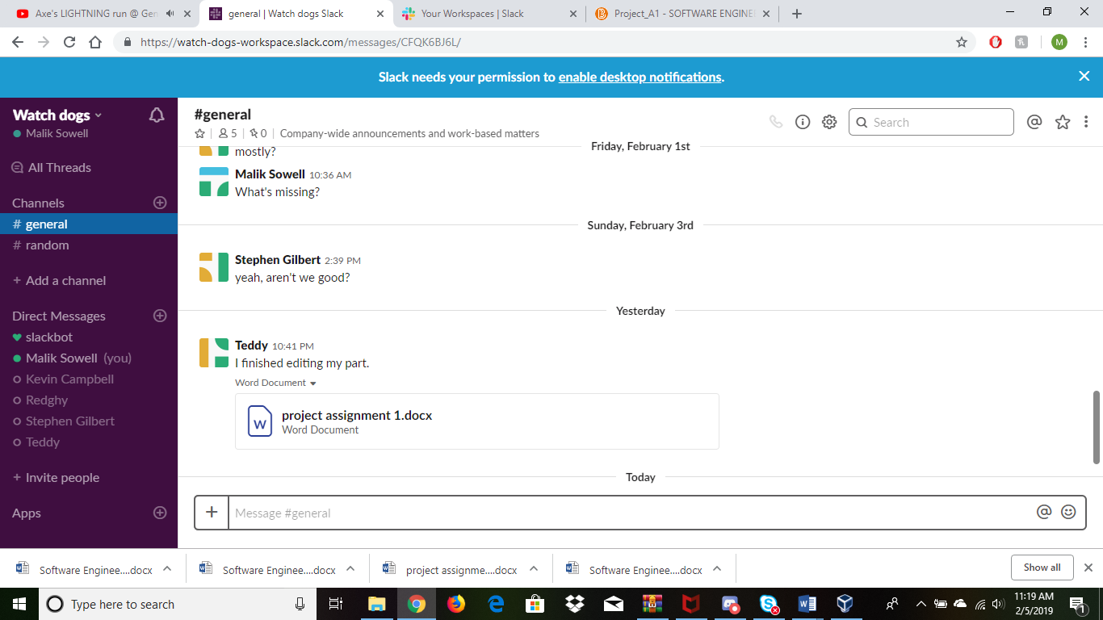

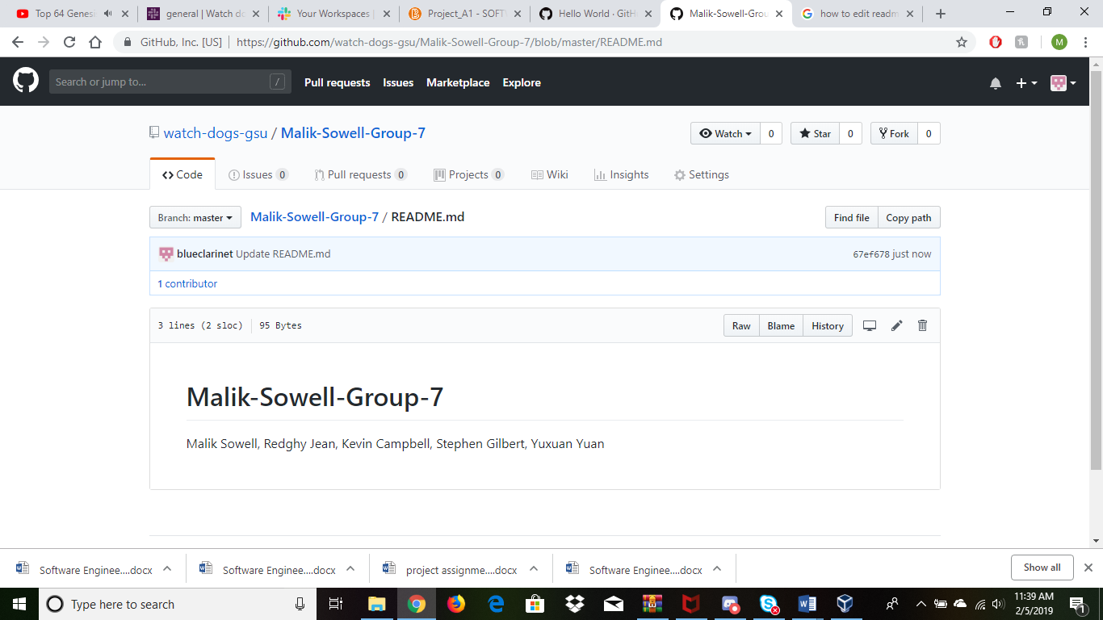

Resume:

Name: Stephen Michael Gilbert

Past experience: Worked on several game-producing projects, spent a few years working on Alexa skill development.

Language Familiarity: Passingly Capable of Python, Bash, Assembly, C#, C++, but most familiar with Java.

Name: Yuxuan Yuan

Past experience: Worked on a database system of Movie Theater and several projects on file manipulation.

Language Familiarity: Java, C#, Assembly, Bash, SQL

Teamwork Basics:

Summarize the following sections in the Teamwork Basics documents using your own words and must provide examples using personal experience (at least two group members) in this class or other classes or internships:

Teamwork Basics:

Work Norms: Everyone needs to agree on how the work will be distributed and managed. The coordinator needs to assign tasks and deadlines, but also listen to people’s feedback on what they feel well equipped to handle, and over what period. One of the big concerns is what happens if someone fails to do their work, or does work that isn’t up to par, which usually falls to the coordinator to manage. The biggest take away is that when people need to figure out how the work gets done, we need to talk about it. Stephen can attest to experiences last semester in a group project with work that needed to be done in sequence. Fortunately, with that group we were able to consistently get things done, but there were a few times where people were cautious or even worried about getting things done before subsequent assignments could be completed.

Facilitator Norms: We have a group coordinator, though anyone who is willing to step up and facilitate is welcome to do so. Stephen had an experience where a member of the group stepped up to an assignment that was popped on the group over a break, where the group member (unnamed) took the lead to schedule how things could be taken on over the significantly shortened timeframe, before the actual coordinator could get a handle on the situation.

Communication Norms: It is important to coordinate and communicate in a way that every member of the group can access, that additionally will make it easy for relevant information to be shared and congregated. Stephen suggested Slack from his personal experience using it in past projects.

Meeting Norms: Scheduling is difficult, especially with intermittent conflicts and personal crises. Even already we’ve had a surprise issue with the inclement weather causing a meeting to be canceled. Good communication is key to rescheduling and allowing important meetings to happen when necessary, and for catching people up to what they’ve missed. Yuxuan had an experience. When someone didn’t show up in the meeting, the coordinator or someone else posted the important points from the meeting to the communication media. After that, the person who missed the meeting also talked with us in a timely manner.

Consideration Norms: Be polite. Since we’ve been meeting in the Library, and likely will continue to do so, there’s not much to be ‘considered’ since we’re beholden to their own rules—smoking and eating are already largely out of the question. When someone is dominating the discussion, it is best to defer to the coordinator or facilitator, as should be done when someone is uncomfortable with what is going on in the team. Yuxuan had a discussion experience. Someone had a new idea about the project. He talked with the coordinator first. The coordinator thought it was an interesting idea, so he brought it up to the group for discussion. The coordinator made the final decision based on the current situation and everyone agreed.

Handling Difficult Behavior:

When someone is overly talkative, it’s important to remind them to let others share the stage, politely yet firmly. This is a group project. Likewise when the inverse is true, it’s important to reach out to people who aren’t and encourage them to share their perspective on the problem.

When a group member is overly argumentative, it’s vital to remember that sometimes their critique can be very helpful! That said, if they’re being overly critical of other group members, that’s no good, and should be discouraged. This is also the state for complaints: you have to draw a line between ‘helpful’ complaints and ‘unhelpful ones. It’s not an easy division to make

Handling Group Problems:

Floundering: It’s easy to find yourself unable to make progress as fast as you might be able to. One excellent way to keep things moving is to make task lists that help you better grasp what needs to be done in what order. We’ve even seen this already in completing this very project!

Tangents: Even getting along well as a group is not without its downsides; it can be easy to fall into the habit of going off topic in casual conversation when there’s work to be done. Some of this is just a healthy part of the group dynamic, but you should always remember to try and stay on topic, reining in the conversation to bring it back to the original topic.

Deciding Too Quickly: At times, one member of the group might be ready to go forwards with a plan without the rest of the group being on-board. When this happens, it’s important to make sure everyone is on the same wavelength. Don’t let one person alone force the group down a certain path if the rest of the group isn’t so certain.

Not Deciding: On the other hand, failing to decide is potentially much worse. How do you finish the assignment if you can’t plan! There are two recommended approaches to resolving this. One is putting it up to a vote, with each person voting for their top, oh, half of the options. Whatever options has the highest vote count, and work out the similarities between them, then work out the top options of those and repeat till you’ve settled on a plan. The other is to follow the Plan A process, which is more for quick decisions, and emphasizes selecting a single option out of the gate rather than the sequential voting of the former strategy.

Feuding: Conflict between group members is potentially disastrous. The best strategy is to have the conflicting parties discuss their problems and use the listening techniques from this document.

Ignoring and Critiquing Others: Excluding singular members of the group can cause great amounts of conflict. It is vital to make great effort to work with each other group member.

Doesn’t Do Their Share of the Work: If one person isn’t getting their work done, it is important to remind them that their actions affect the group, not just themselves. We’re in this together, as a team.

**User Requirements**

First, read Ch4 page 88-90.

-

What is your product, on a high level?

* Our product is a consumer friendly product that enables the user the ability to locate competitive prices in nearby markets on the groceries that he or she may buy in order to purchase the item at the best price.

Whom is it for?

* It is for the everyday shopper and the budget consumer.

What problem does it solve?

* It solves the problem of not knowing where to get whatever grocery item at the best price possible, along with quality and food cost comparison of the market that the consumer may attend.

What alternatives are available?

* Alternatives to our product would be a much slower paced manual comparison. The consumer themselves would have to go in the store to attest to the specifics, and research the markets themselves in order to see what fits their own budget.

Why is this project compelling and worth developing?

* This project is compelling and worth developing due to the fact it can be marketed towards large demographics such as college kids and the average budget consumer. The project could also become a key difference maker and helpful tool that saves the consumer some extra money.

Describe the top-level objectives, differentiators, target customers, and scope

of your product.

* The top level objective of our product is providing accurate information in regard to the consumers prompted comparisons, our target customers will be college students and lower budget consumers. Our biggest differentiators are ease of access, and alternative item selections. Our product will be a downloadable app offering local market comparisons based on your current location, along with best price matches and lower priced alternatives (ex. Off-brand items).

What are the competitors and what is novel in your approach?

* There are currently no big viral competitors in this particular area. The closest adversary would be Wal-Mart’s price match. Our approach into this area kicks it up a notch by enabling the user to access comparisons and cheaper alternatives of their choosing by the touch of their finger, rather than having to go to the store and prove to an employee that an item is cheaper in another market all in order for them to match the price.

Make it clear that the system can be built, making good use of the available resources and

technology.

-

What is interesting about this project from a technical point of view

* From a technical point of view, this project is intriguing due to the fact it can be applied to a real world everyday scenario. It is an idea worth developing because of the sheer practicality and reusability it could have.

**Hardware Architecture:**

Grocery shopping system

Inventory system

Return system

Product system

Checking out system